Trường TH Tân Nhựt 6

PHIẾU HỌC TẬP MÔN TIẾNG ANH LỚP 2
TUẦN 34, NĂM HỌC 2020 – 2021
(Ngày 10 tháng 5 năm 2021)

Họ và tên học sinh:
Lớp: 2/.....

UNIT 7: ARE THESE HIS PANTS?
PART 1. THEORY
I. Vocabulary:
- dress
- socks
- T-shirt
- pants
- shorts
- shoes
- coat
- hat
II. Structures:
- This is her hat.
- These are his shorts.
- Are these her socks?
Yes, they are.
- Are these his pants?
No, they aren’t.
- What color are these pants?
They’re pink.
- What color is this dress?
It’s red.
PART 2. PRACTICE
I. Look and write.
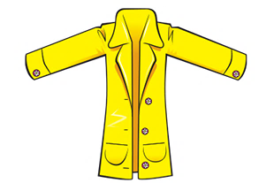
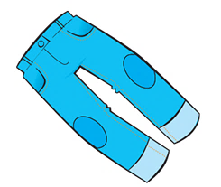
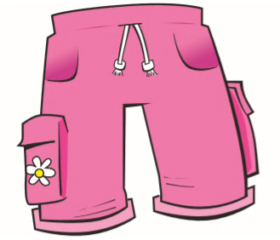
1 2 3

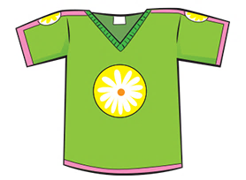
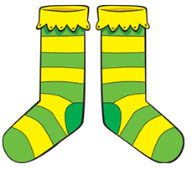
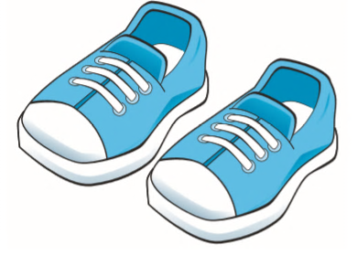
4 5 6

II. Order the words.
1. are / pants / . / These / her

2. his / These / shoes / are / .

3. are / . / they / , / Yes

4. her / socks / are / . / These

5. his / ? / these / socks / Are

6 coat / is / . / his / This

THE END

